DOCTOR ‘YOU’ - if you could travel through time and see yourself
My Dream Career
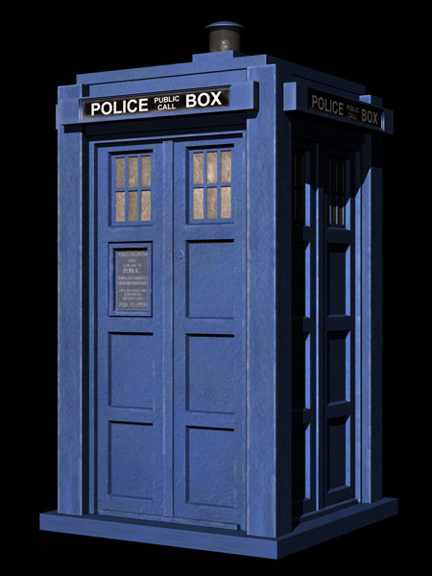
20 years’ into the future...

